MAWLANA BHASHANI SCIENCE AND TECHNOLOGY UNIVERSITY
SANTOSH, TANGAIL-1902



DEPARTMENT OF INFORMATION AND COMMUNICATION TECHNOLOGY
Lab Report No: 03
Course Title: Database Management System Lab
Course Code: ICT-2108
Lab Report on: Different Types of Select Operations in MySQL.
Submitted By | Submitted To
Name: MD. Atick Israk  ID: IT-22040  2nd Year, 1st Semester  Session: 2021-2022  Dept. of ICT, MBSTU | Dr. Md. Abir Hossain  Associate Professor  Department of Information and Communication Technology.  Mawlana Bhashani Science and Technology University

Date of Performance: 12-03-2024 Date of Submission: 19-03-2024

Experiment No: 03
Experiment Name: Basic query of MySQL.
Objective: The main objective of this experiment is to use some basis query of MySQL. We will learn how to show different attributes from database and also learn how arithmetic expressions work in database.
Required Instruments :
- MySQL 8.3 Command line Client.

Finding the names of all instructors:
SQL expression: select name from instructor;

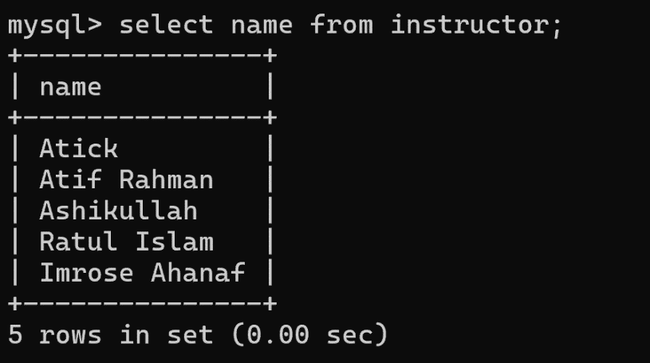

Finding the department names of all instructors:
SQL expression: select dept_name from instructor;
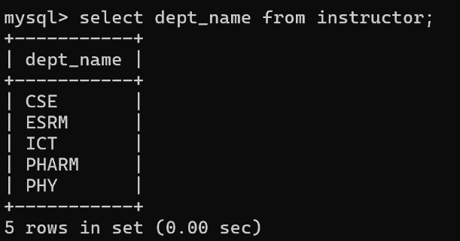

Finding the distinct department names of all instructors:
SQL expression: select distinct dept_name from instructor;
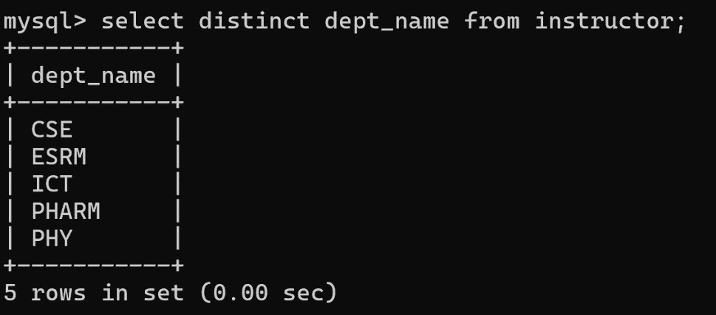

Finding the all department names of all instructors.
SQL expression: select all dept_name from instructor;

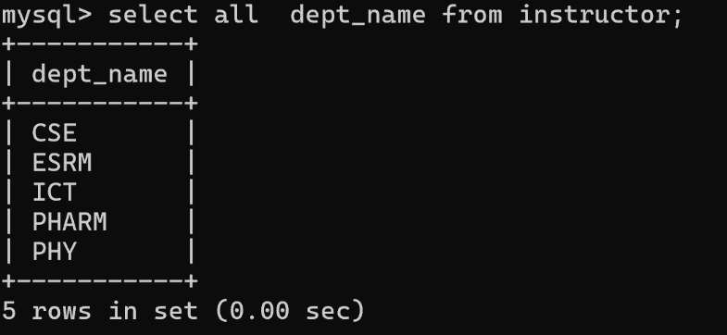

The select clause may also contain arithmetic expressions involving the operators +, −, ∗, and / operating on constants or attributes of tuples. For example, the query:
SQL expression: select ID, name, dept_name, salary *1.1 from instructor;
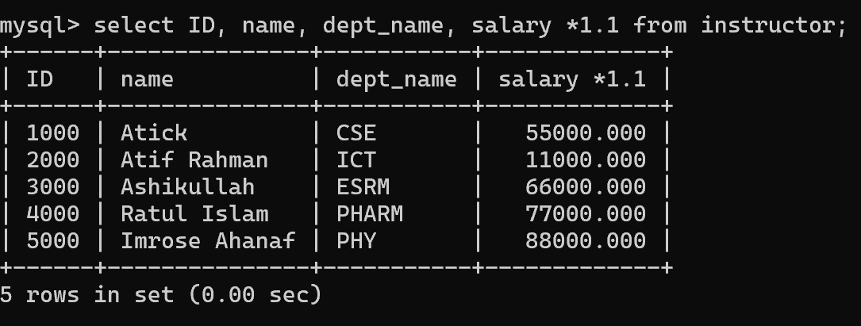
Finding the names of all instructors in the ICT department who have salary greater than 30,000:
SQL expression: select name from instructor where dept_name=”ICT” and salary>30000;

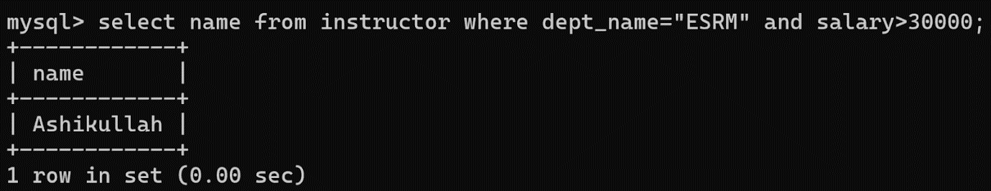
Finding the names of all instructors, along with their department names and department building name.
SQL expression: select name, instructor.dept_name, building from instructor, department where instructor.dept_name=department.dept_name;

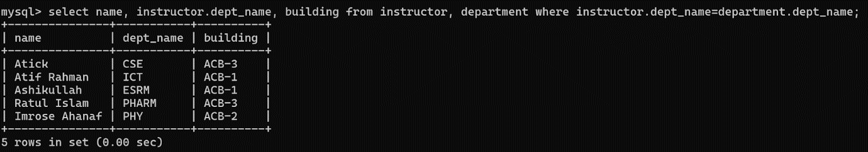
Discussion: Using the above queries we can easily find our desired attributes. We can use arithmetic expression to find desired values.

